

# 

### Semester One Examination, 2017

### Question/Answer booklet

# MATHEMATICS

**METHODS**

**UNIT 1**

## Section Two:

## Calculator-assumed

Your name

## Time allowed for this section

Reading time before commencing work: ten minutes

Working time: one hundred minutes

## Materials required/recommended for this section

***To be provided by the supervisor***

This Question/Answer booklet

Formula sheet (retained from Section One)

***To be provided by the candidate***

Standard items: pens (blue/black preferred), pencils (including coloured), sharpener, correction fluid/tape, eraser, ruler, highlighters

Special items: drawing instruments, templates, notes on two unfolded sheets of A4 paper, and up to three calculators approved for use in this examination

## Important note to candidates

No other items may be taken into the examination room. It is **your** responsibility to ensure that you do not have any unauthorised material. If you have any unauthorised material with you, hand it to the supervisor **before** reading any further.

## Structure of this paper

|  |  |  |  |  |  |
| --- | --- | --- | --- | --- | --- |
| Section | Number of questions available | Number of questions to be answered | Working  time (minutes) | Marks available | Percentage of examination |
| Section One:  Calculator-free | 7 | 7 | 50 | 52 | 35 |
| Section Two:  Calculator-assumed | 13 | 13 | 100 | 98 | 65 |
|  | | |  | **Total** | 100 |

## Instructions to candidates

1. The rules for the conduct of examinations are detailed in the school handbook. Sitting this examination implies that you agree to abide by these rules.

2. Write your answers in this Question/Answer booklet.

3. You must be careful to confine your response to the specific question asked and to follow any instructions that are specified to a particular question.

4. Additional working space pages at the end of this Question/Answer booklet are for planning or continuing an answer. If you use these pages, indicate at the original answer, the page number it is planned/continued on and write the question number being planned/continued on the additional working space page.

5. Show all your working clearly. Your working should be in sufficient detail to allow your answers to be checked readily and for marks to be awarded for reasoning. Incorrect answers given without supporting reasoning cannot be allocated any marks. For any question or part question worth more than two marks, valid working or justification is required to receive full marks. If you repeat any question, ensure that you cancel the answer you do not wish to have marked.

6. It is recommended that you do not use pencil, except in diagrams.

7. The Formula sheet is not to be handed in with your Question/Answer booklet.

Section Two: Calculator-assumed 65% (98 Marks)

This section has**thirteen (****13)** questions. Answer **all** questions. Write your answers in the spaces provided.

Working time: 100 minutes.

Question 8 (6 marks)

(a) The variables and are directly proportional to each other, so that when , it is known that . Sketch a graph of the relationship between and on the axes below. (3 marks)

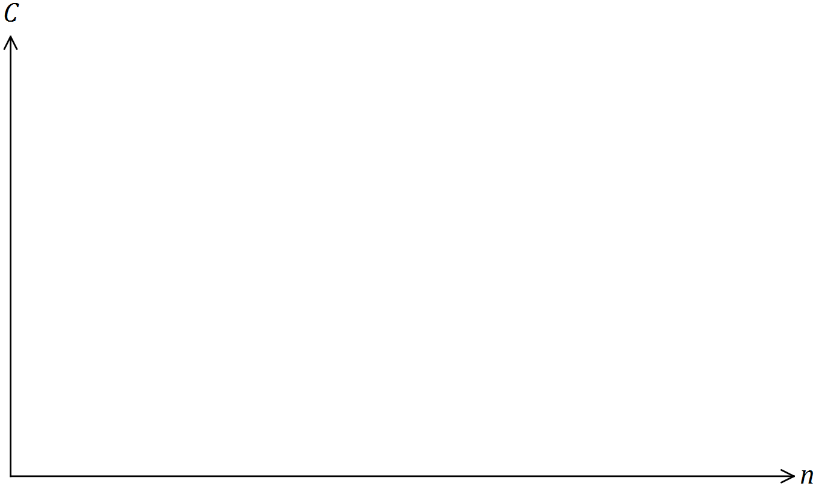

(b) The variables and are inversely proportional to each other, so that when , it is known that .

(i) Write an equation that relates and . (2 marks)

(ii) Determine the value of when . (1 mark)

Question 9 (9 marks)

(a) Determine the size, to the nearest degree, of the largest angle in a triangle with sides of lengths 23 cm, 28 cm and 31 cm. (3 marks)

(b) Determine the value of in the diagram below. (3 marks)

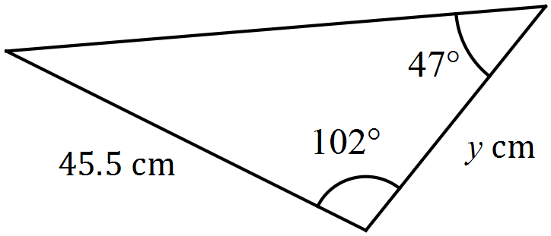

(c) The area of the triangle shown below is 280 cm2. Determine the value of . (3 marks)

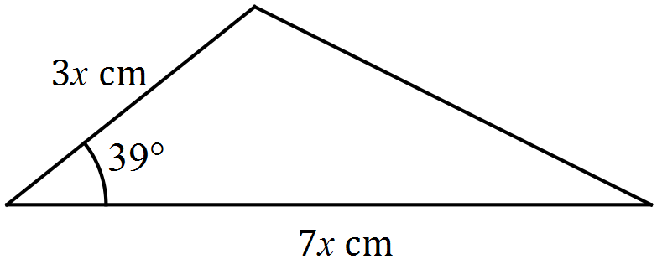

Question 10 (6 marks)

(a) State, with reasoning, which of the graphs shown below are **not** those of a function.

(3 marks)

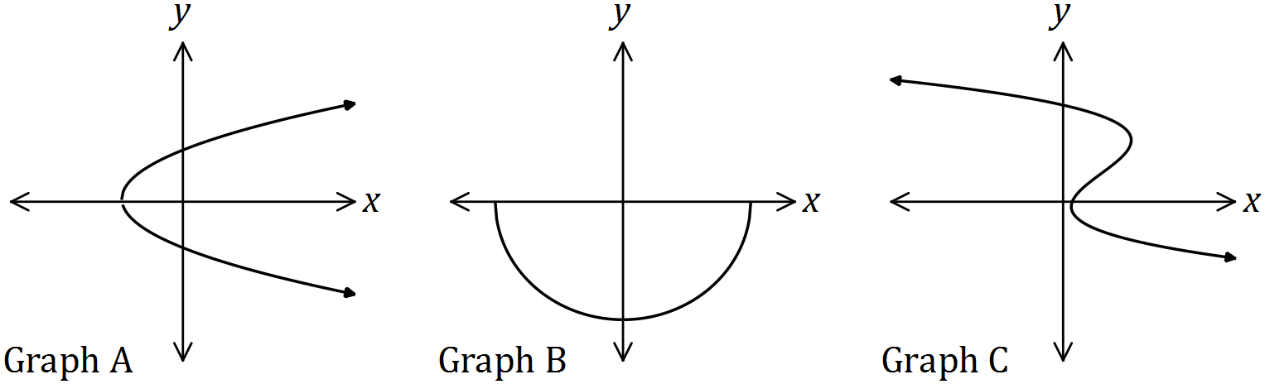

(b) Draw the graph of the relation . (3 marks)

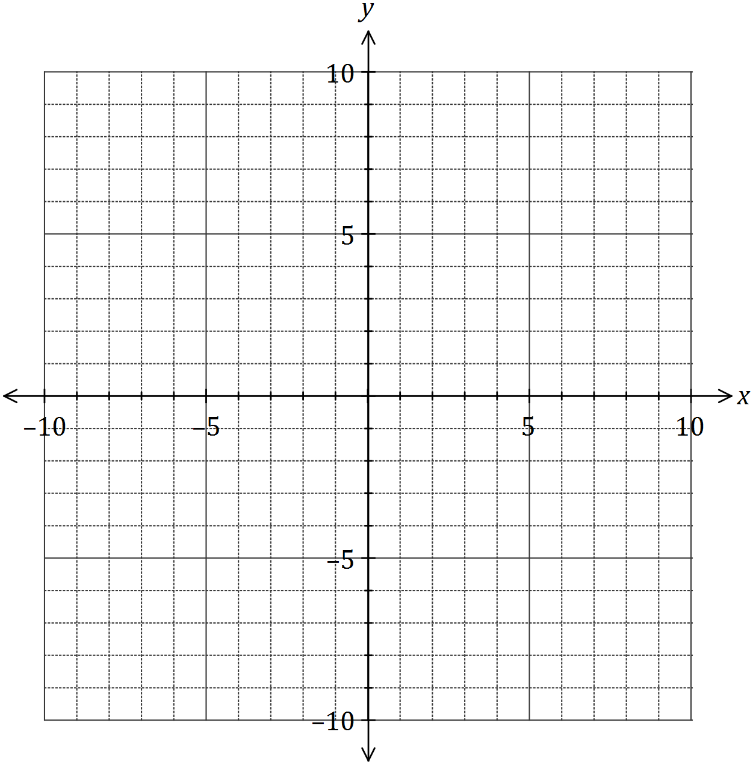

Question 11 (6 marks)

(a) The graphs of and are shown below.

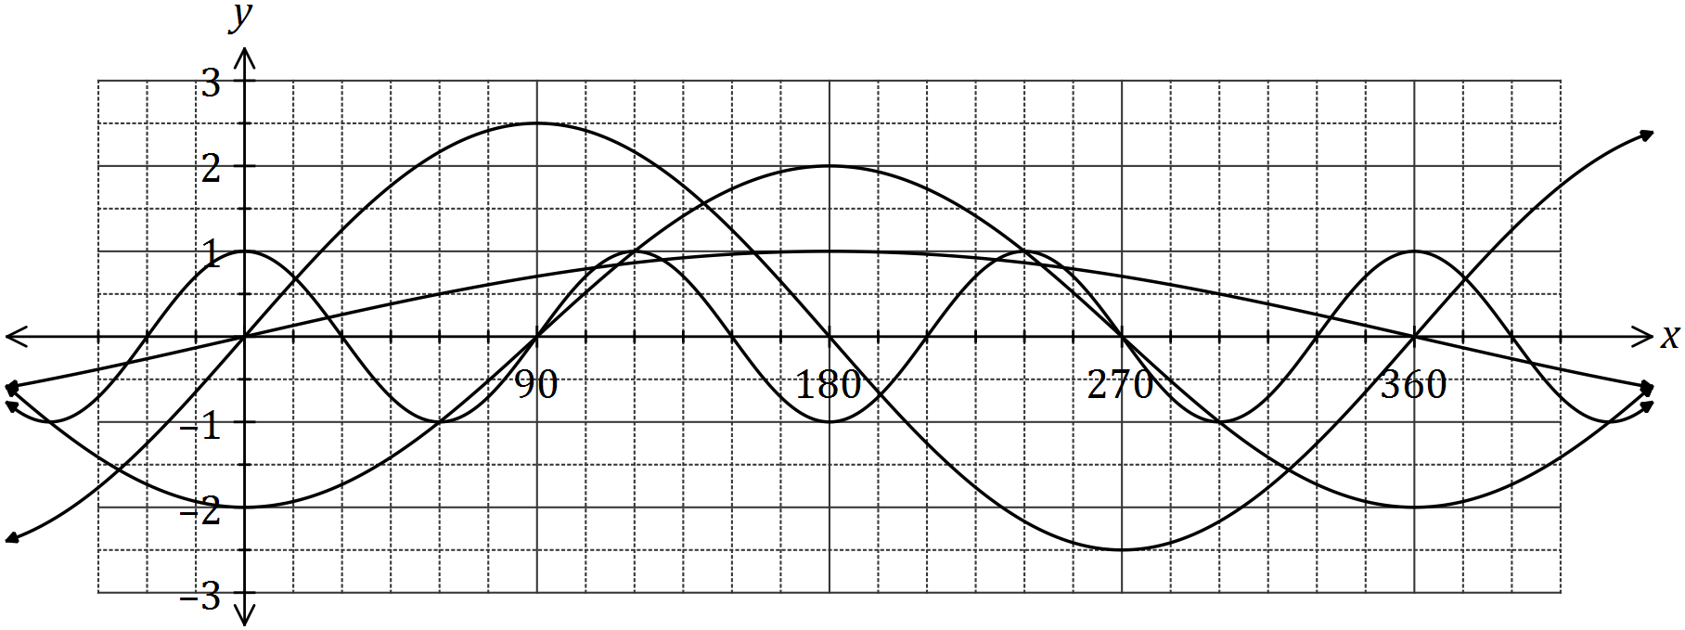

Determine the values of the constants and . (4 marks)

(b) The graph of is drawn below.

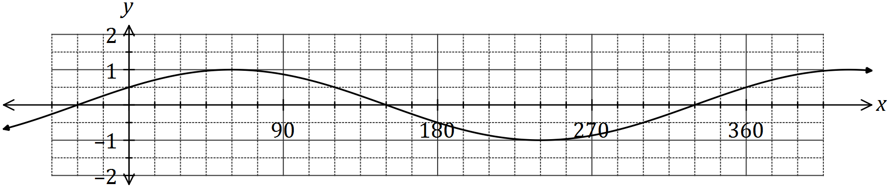

(i) State the value of the constant , where . (1 mark)

(ii) The graph is also that of . State the value of the constant , where . (1 mark)

Question 12 (8 marks)

(a) At 3 pm, the length of the shadow of a thin vertical pole standing on level ground is the same as the height of the pole. A while later, the angle of elevation of the sun has decreased by 12° and the length of the shadow has increased by 95 cm. Determine the height of the pole. (4 marks)

(b) A windscreen wiper on a car is 43 cm long and rotates through one-third of a circle, as shown below. The inner and outer radii of the arcs are 20 cm and 63 cm. Determine the shaded area, rounding your answer to a reasonable degree of accuracy. (4 marks)

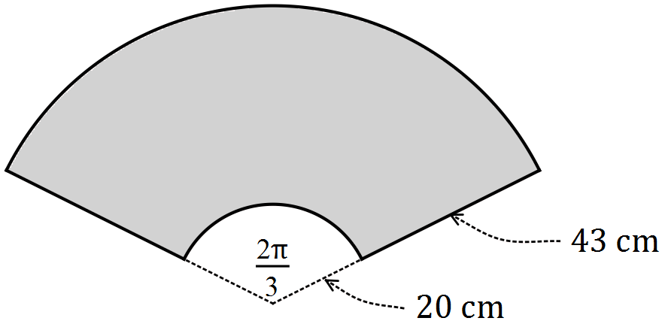

Question 13 (5 marks)

(a) Using the unit circle shown, determine the following in terms of and/or , given that is an acute angle measured in degrees.

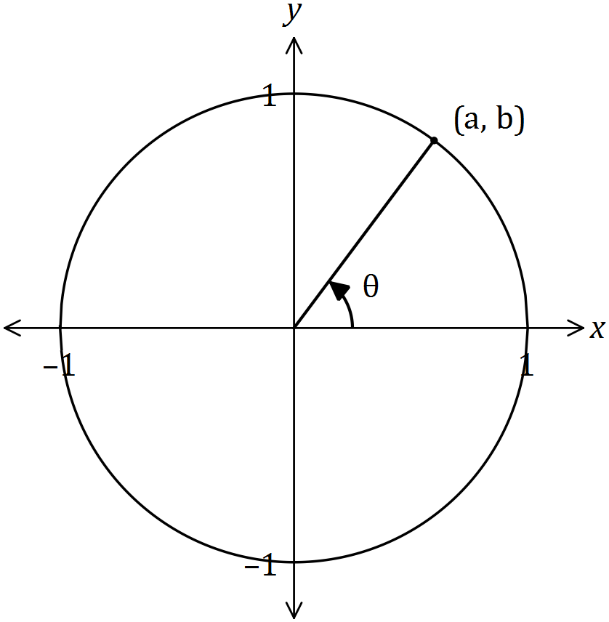

(i) (1 mark)

(ii) . (1 mark)

(iii) . (1 mark)

(b) Determine in each of the following cases, where .

(i) . (1 mark)

(ii) . (1 mark)

Question 14 (8 marks)

(a) The graph of has a line of symmetry with equation .

(i) Determine the value of . (2 marks)

(ii) Draw the graph of the parabola on the axes below. (3 marks)

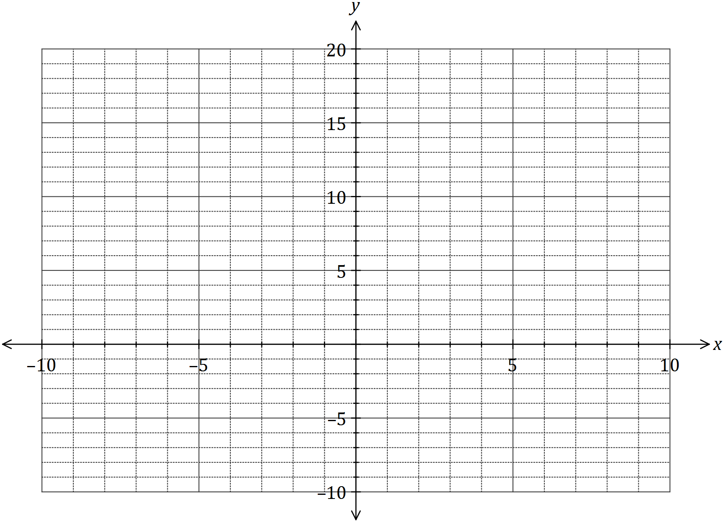

(b) One of the solutions to the equation is . Determine the value of and all other solutions. (3 marks)

Question 15 (8 marks)

(a) On the axes below, draw the graph of over the interval , clearly indicating the equations of any asymptotes. (3 marks)

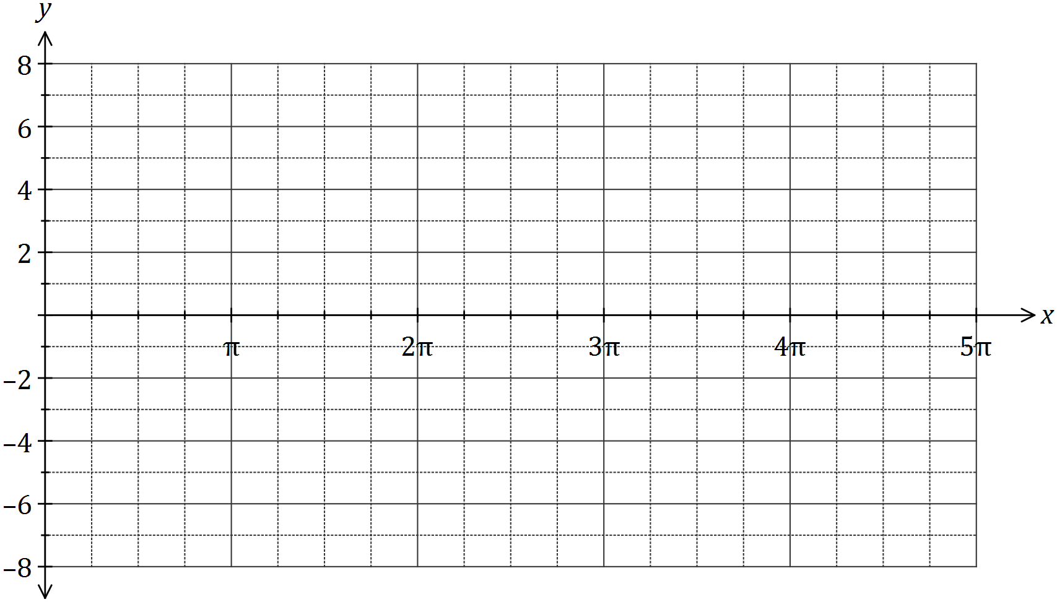

(b) Solve the following equations over the interval .

(i) . (1 mark)

(ii) . (2 marks)

(c) Determine the smallest positive value of so that . (2 marks)

Question 16 (8 marks)

The graph of the function is defined by is shown below.

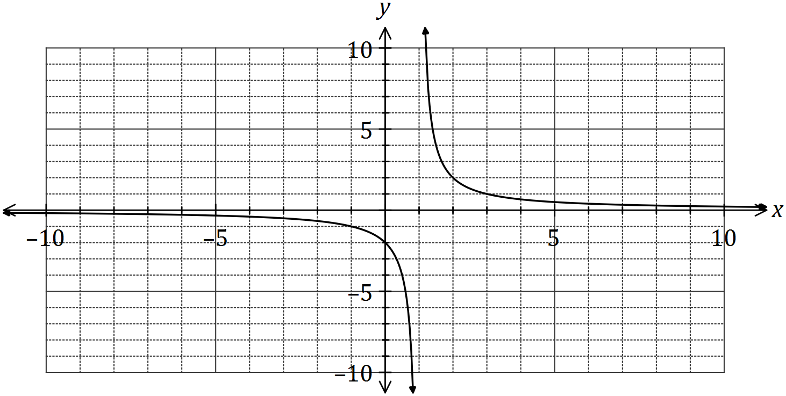

(a) Determine the values of and . (2 marks)

(b) State the domain and range of . (2 marks)

(c) Determine the equations of the asymptotes of the graph of . (2 marks)

(d) Describe the transformation required on the graph of to obtain the graph of

(i) . (1 mark)

(ii) . (1 mark)

Question 17 (9 marks)

A straight line with equation , a parabola with equation and a cubic with equation all pass through the points and .

(a) Determine the values of the constants and in the equation of the straight line.

(2 marks)

(b) Determine the values of the constants , and in the equation of the parabola, given that is a minimum turning point of the parabola. (3 marks)

(c) Draw the graph of the cubic on the axes below, given that is a point of inflection and is a maximum turning point of the cubic. (4 marks)

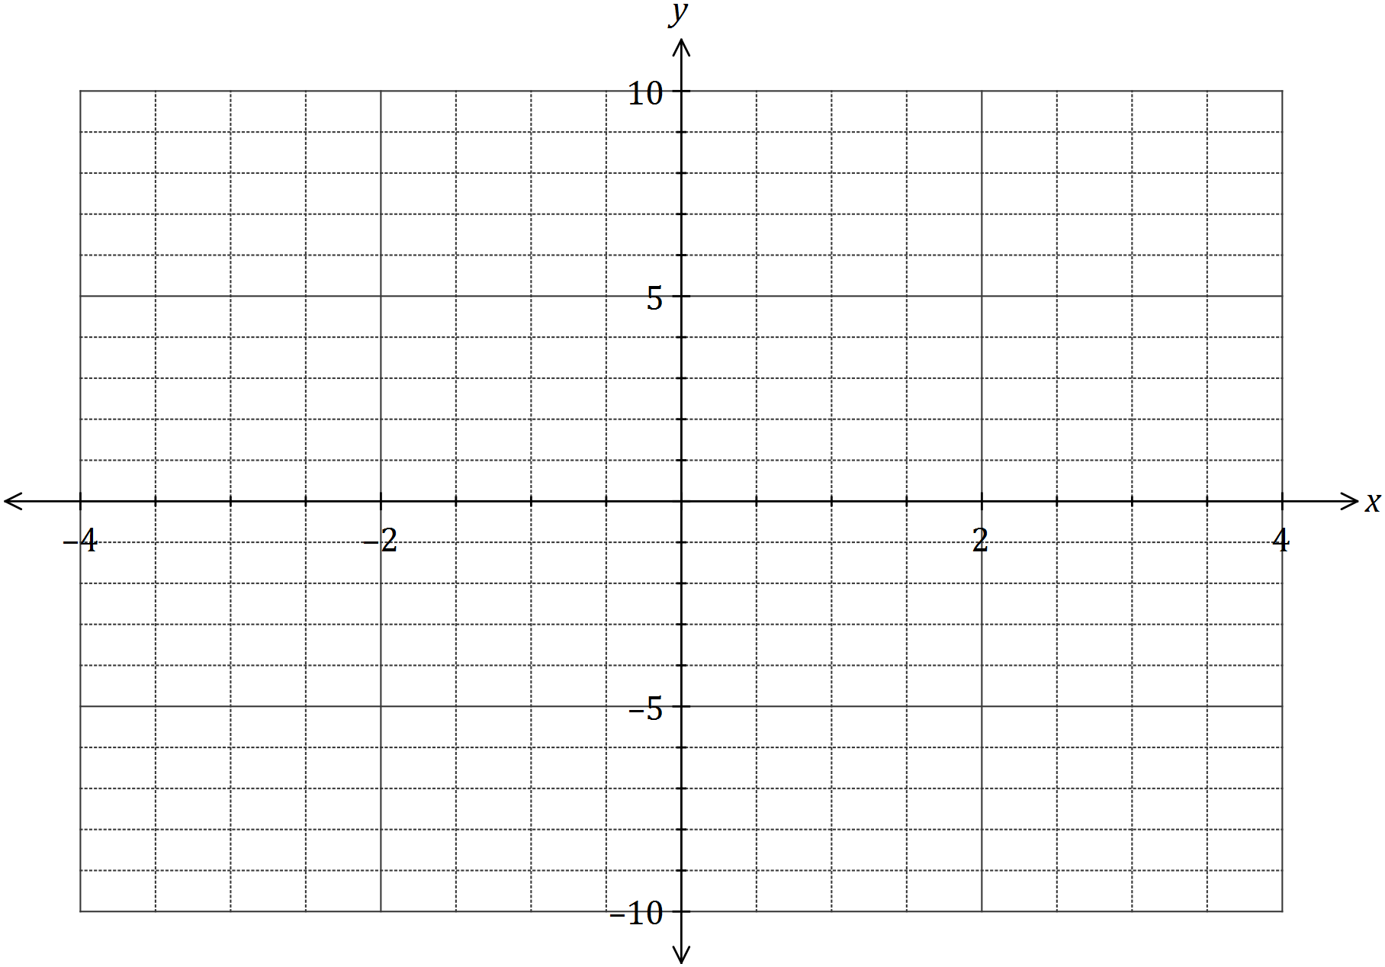

Question 18 (8 marks)

Over a 24-hour period, the depth of water, metres, in a harbour at time hours after midnight was given by

(a) Determine the depth of water at 11 pm. (1 mark)

(b) Draw the graph of the water depth on the axes below. (3 marks)

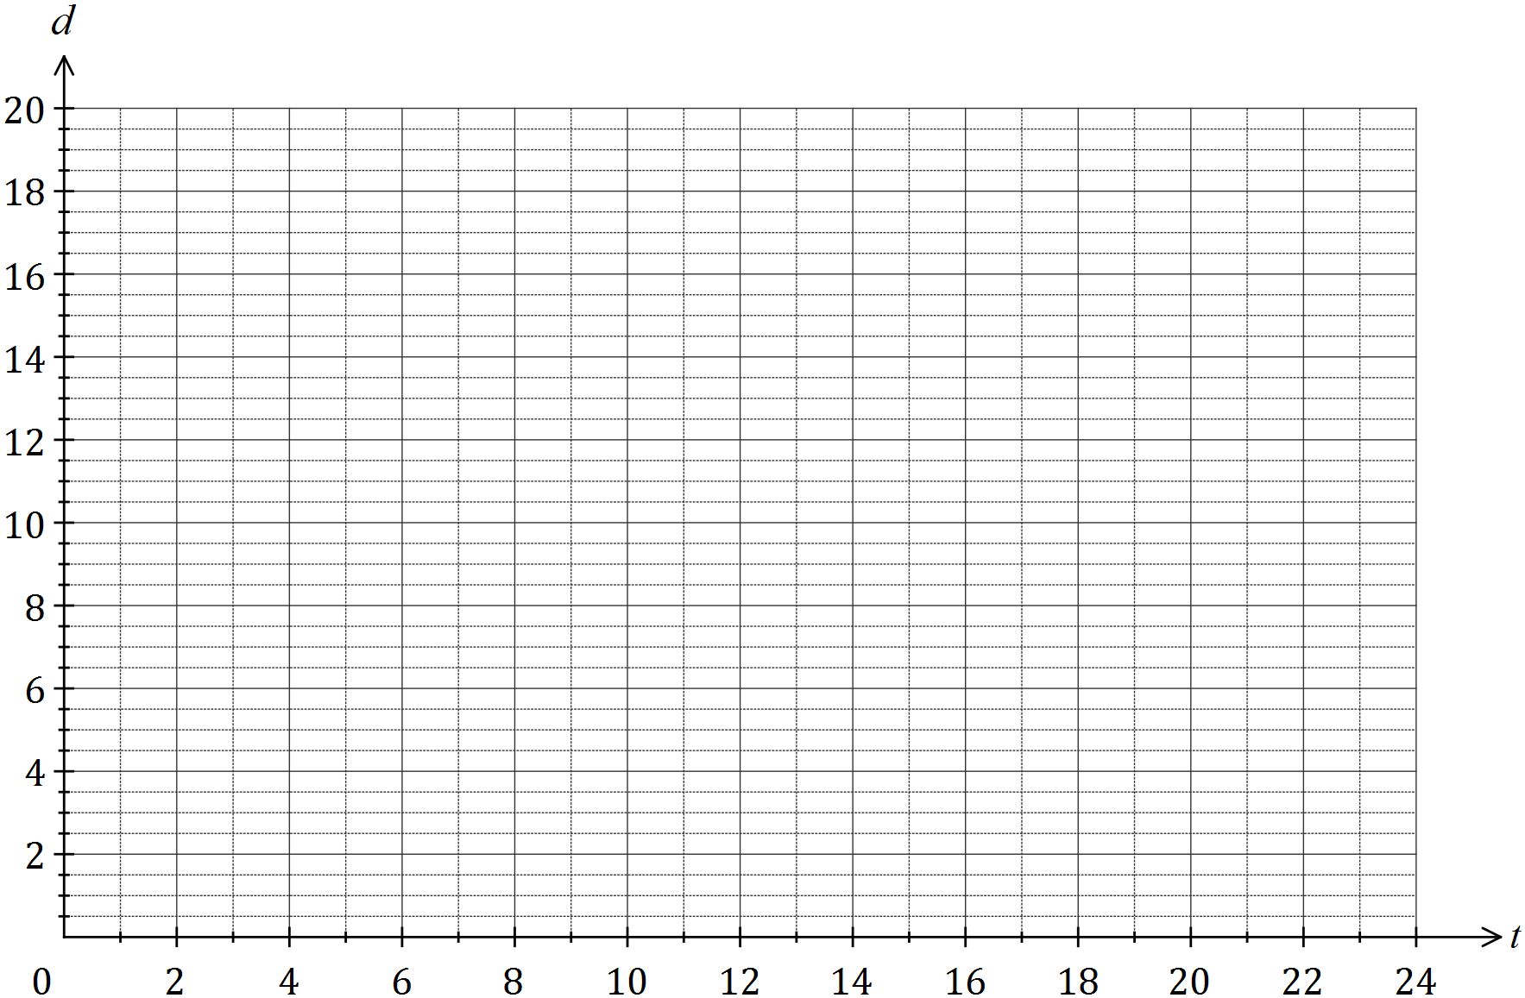

(c) At what time, in hours and minutes, did the depth of water first exceed 15 metres?

(2 marks)

(d) Determine the fraction of the 24-hour period during which the depth of water exceeded 12.75 m. (2 marks)

Question 19 (8 marks)

The graph of is drawn below over its natural domain, where .

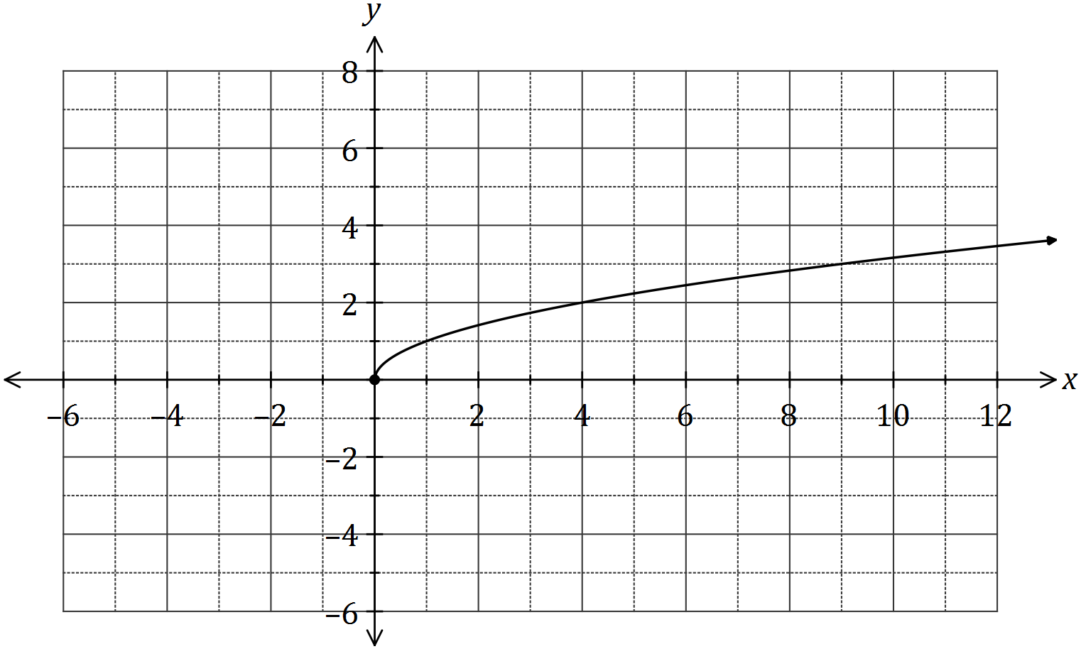

(a) The value of is either or . State the correct value of and justify your choice. (2 marks)

(b) Explain why the domain of the function is . (2 marks)

(c) On the axes above, sketch and label the graphs of

(i) . (2 marks)

(ii) . (2 marks)

Question 20 (9 marks)

(a) A running track has circular ends of radius 100 m and two straight, parallel sides and that are both 120 m long, as shown below. Determine, to the nearest metre, the total length of the track. (4 marks)

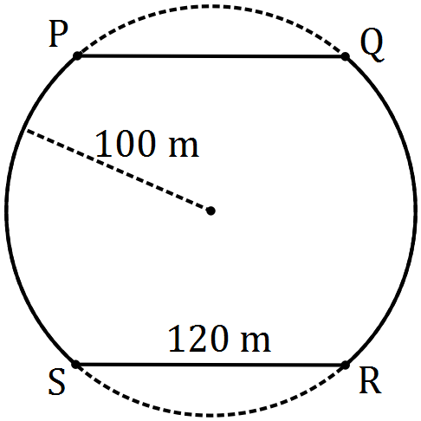

(b) The diagram shows a circle with centre and diameter , and an equilateral triangle . Determine the exact fraction of the area of the circle that lies outside the triangle.

(5 marks)

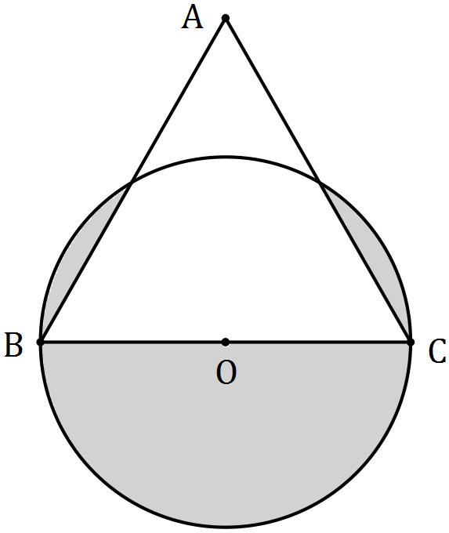

Additional working space

Question number: _________

© 2016 WA Exam Papers. Kennedy Baptist College has a non-exclusive licence to copy and communicate this paper for non-commercial, educational use within the school. No other copying, communication or use is permitted without the express written permission of WA Exam Papers. SN245-092-7.